**Patient Information Leaflet**



**Duke Street Surgery is a partnership providing NHS Services under an NHS England General Medical Services Contract**

**4 Duke Street, Barrow in Furness, Cumbria, LA14 1LF**

**Telephone: 01229 820068**

**Email Address:**  **lscicb-mb.dukestreet@nhs.net**

**Website:** [**www.dukestreetsurgery.nhs.uk**](http://www.dukestreetsurgery.nhs.uk)

**Doctors**

Dr Ruth Wilkinson MBBS., MRCGP

Dr Alistair Harrison BMBCh., MRCGP., DRCOG

Dr Nandini Das MBBS., DFFP., MRCGP., DRCOG

Dr Kalyani Rajasooriyar MBChB., MRCGP

Dr Cian Nutt MCChB., BMedSci., MRCGP

Dr Helen Green MBBS., MRCGP

Dr Lakshan Gunasinghe MBBS., MRCGP

Karen Postlethwaite (Nurse Practitioner) RGN., BSc(Hons)., NP., MSc., FCC

Emma Gaitskell (Advance Nurse Practitioner) RGN., BSc., NP., MSc

**Practice Manager**

Laura Hodgkinson

**The Practice Team**

This practice operates under a partnership agreement and provides services on behalf of the NHS.

**Mental Health Practitioner**

Katy Hornby (Appointments available Monday, Wednesday & Friday)

**Practice Nurse Health Care Assistant (HCA)**  Christine Turner Cheri Johnston Catherine Hartlebury Julie Bryan Rebecca Gee Vikki Benson (NA) Keeley Grierson Deryn Grierson

**Services we provide**

Along with routine appointments the practice offers the following services:

* Contraception Services - All our GP’s Nurse Practitioner and Practice Nurses offer a full range of contraception services
* Immunisations – The Nursing Team administers vaccines for both adult and children. We hold the childhood immunisation clinic on Monday mornings, if this is not convenient, we can offer you an appointment on other weekdays
* Baby & Postnatal Reviews – These are arranged by our Admin Team between 6-8 weeks after baby is born and are normally done at the same time as the first immunisations
* Minor Surgery – Your GP will advise on minor surgery, these are done on Tuesday mornings
* Cervical Screening Testing – For women aged 25-65. These tests are undertaken by the Nursing Team, and we can offer appointments Monday – Saturday
* Mental Health Practitioner – The practice has an inhouse Mental Health Practitioner, to make an appointment please discuss with the Reception Team
* Well Man and well women clinics, over 75 Health Checks- These are undertaken by the Health Care Assistants and aimed at encouraging a healthy lifestyle for our male & female population
* Free NHS Health Checks (40-75) – When patients turn 40, they will automatically be invited for a free NHS Health Check, this will be repeated every 5 years until the age of 75
* Phlebotomy- These appointments are undertaken by our Health Care Assistants; blood tests can be booked only if they have been requested by a GP or Nurse
* Wound Care – Simple & complex dressings, Suture and staple removals are carried out by our Practice Nurses and HCA’s
* Sexual Health Services- Our Practice nurses can offer level 1 & 2 sexual health screening, for more information please discuss with the reception team
* Travel Consultations & Immunisations- The Nursing Team offer full travel consultations and immunisations if needed. Please make sure you allow plenty of time to make your appointment before you travel
* Chronic Disease Management- We hold a range of clinics to help our patients to manage their long-term medical problems including asthma, COPD, diabetes, hypertension, kidney disease and heart disease. Patients will be recalled on an annual or six-monthly basis for a review of their ongoing conditions that require clinical management

From time-to-time other services may be available such as raising awareness of a particular disease or condition. We will advertise this information on our website and within the practice.

**Appointments and accessing the practice services**

To make an appointment to see your GP or any member of our healthcare staff or to access any other of our practice services, please log on to the practice website at [www.dukestreet@nhs.uk](http://www.dukestreet@nhs.uk), via one of the online patient access apps such as the NHS APP, for more information please as a member of our Reception team. Should you be unable to access the website or one of the apps please ring 01229 820068 and a member of our reception team will be able to assist you.

The Practice Website contains all the relevant practice information that you are likely to require. It is the quickest way to access the services you may need.

**Prescriptions/Repeat Prescriptions**

Your GP will initiate any prescriptions that they determine you require. Repeat prescriptions can be order in the following way:

1 Via one of the online patient access applications (NHS APP or Patient Access) for more information please speak to the Reception Team

2 By emailing your request including your name, date of birth and address to lscicb-mb.dukestreet@nhs.net

3 In person by ticking the required medication on the right side of your prescriptions and posting it through the post box at the front of the building

**Please allow 3 days for collection from your nominated pharmacy (excluding weekends and bank holidays)**

**Carers**

If you are a carer for anyone, please inform the practice so that your record can be updated. This will enable the team to provide you with any support you may require.

The Practice works closely with Furness Carers, for more information please contact our Carer Champion Cat on 01229 820068 for more information.

**Practice Learning Time**

The practice will be closed for one afternoon per month for GP & staff training, we will update our website, social media & waiting room posters with exact dates when available. During this time if you urgently need medical help or advice and it is life threating dial 999, if it is not life threating contact NHS 111 by calling 111 or accessing via [www.111.nhs.uk](http://www.111.nhs.uk)

**Training Practice**

The practice is a teaching practice and trainee GP’s, Medical Students and Student Nurses may as part of their training be required to sit in with their trainer GP or Nurse Mentors during consultations with patient. You will always be asked if you consent to this prior to your consultation. If you do nor consent the student will not be present during your consultation.

**Home Visits**

Home visits are at the discretion of the GPs and are usually for those patients that are housebound or have significant health issues. These maybe carried out by a member of the Home Visiting Team.

**Patient Participation Group**

We have an active Patient Participation Group (PPG), ensuring that our patients are involved in decisions about the services provided by the practice. Further information about our PPG is available via our website – [www.dukestreetsurgery.nhs.uk](http://www.dukestreetsurgery.nhs.uk), alternatively, contact Kate who is the nominated point of contact for all PPG matters.

**Patient Data**

All clinical and administrative staff have an ethical as well as a legal duty to protect patient information from unauthorised disclosure and in accordance with UK GDPR.

**Threats Of Violence Or Abuse Of Our Staff**

Our staff work hard to provide you with the best possible service. Please treat them with the courtesy and respect they deserve. We operate a zero-tolerance policy and may refuse to provide services to individuals or those accompanying individuals who are violent, threaten violence, commit, or threaten to commit a criminal offence.

**Comments, Suggestions And Complaints**

If you would like more information about any of the services we provide, please ask a member of staff, telephone or visit the practice website. Our aim is to give the highest possible standard of service. We would like you to tell us what you think about the service we offer.

**When We Are Closed**

When the practice is closed, if you urgently need medical help or advice and it is life threatening dial 999. If it is not life threating contact NHS 111 by calling 111 or accessing via [www.111.nhs.uk](http://www.111.nhs.uk)

**Discrimination Policy**

The practice does not discriminate on the following grounds: race, gender, age, social class, religion, sexual orientation, appearance, disability, or medical conditions.

**Patient Responsibilities**

The practice operates a strict DNA policy, we welcome your cooperation in keeping all appointments, please inform the practice as soon as possible if you are unable to attend. You can also cancel your appointment by replying CANCEL to your SMS appointment reminder or via the online patient assess applications. Please note that any patients who displays unacceptable behaviour may be removed from the practice list.

**Opening Hours Improved Access/Extended Access**

Monday-Friday: 8am-6.30pm Monday-Wednesday: 7am-8am

Friday: 7am-8am

The 2nd Saturday of the month: 8.30am-5.30pm

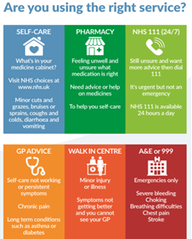

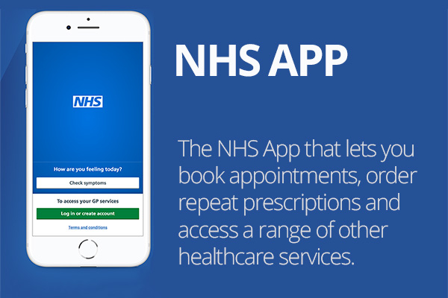

[NHS App and your NHS account - NHS (www.nhs.uk)](https://www.nhs.uk/nhs-app/)

