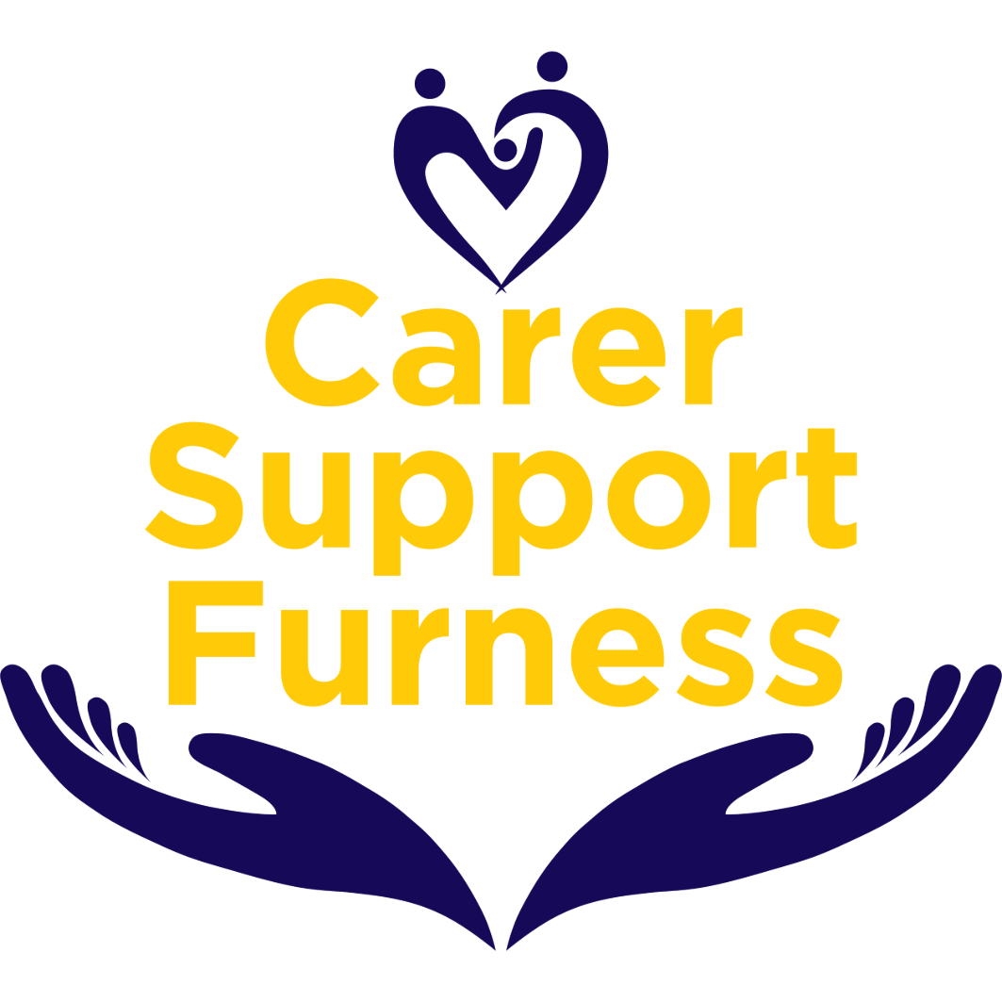

Carers Starter Pack

Unpaid Adult Carers Support Service
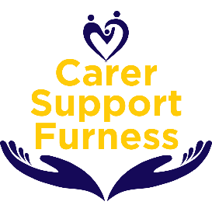





Introduction

Being a carer can be challenging, but support is always available.
If you ever feel unsure, overwhelmed or simply need someone to talk to, please reach out. The services and information listed in this pack are here to guide you, provide practical help, and remind you to look after yourself too. Taking care of yourself is just as important as the care you give to others.

Understanding Your Role as a Carer

You’re a carer if you support someone who could not manage without your help due to age, illness, disability, or mental health needs. This includes emotional, physical, or practical support - even if you’re a family member or friend.
In Barrow in Furness:
Furness Carers provides free support for unpaid adult carers (19+).
Young Carers under the age of 19 can access help via the Young Carers team at Furness Carers. Visit the Furness Carers website to refer to the Carers Services.
Recommendations:
Identify yourself as a carer and contact your GP to let them know you care for someone so that they can support you in your caring role.
Contact the Westmorland and Furness Carers Support Service on 03450 138208 or http://www.wfcarers.org.uk/

Getting Practical Support
Caring can be rewarding but at times can also be isolating. Westmorland and Furness Council and voluntary services provide support to help you manage your caring responsibilities and support you.
Assessments available:
Carer’s Assessment - the assessment focuses on you as a carer, discussing your wellbeing, giving you advice on respite care, equipment, training, emotional support, financial advice and more. Adult carer support | Westmorland and Furness Council
Care Needs Assessment - the assessment evaluates the person you care for to determine whether they require further support, including assistance with daily living activities, mobility, or any home adaptations. Getting a care needs assessment - Social care and support guide - NHS
Blue Badge - if your cared for has mobility issues, you may be able to apply for a Blue Badge to help with parking at appointments - www.gov.uk/apply-blue-badge

Adult Carers Support – Furness Carers
Through our Adult Carers Service at Furness Carers, we offer:
Practical support such as signposting to other support services, emergency planning and registering as a carer with your GP.
Emotional support.
Free, practical training courses and workshops.
Regular social activities to meet other carers and share support.
Carer forums to voice your opinions on topics that matter.
Quarterly newsletters and updates.
Support with Carers Trust Grant Applications (if eligible).
Support with arranging overnight breaks.
Recommendations:
Read the information on the Furness Carers Website or Facebook page.

Adult Carers Support – Westmorland and Furness Carer Support Service
Dedicated support
Get personalised one-to-one support to help you in your caring role.
Carers Help and Talk (CHAT) Line
Speak with a friendly volunteer here to provide a listening ear over the phone.
Carers assessment & support plan
Have a simple conversation to explore your needs and create a support plan that works for you.
Pen Pal
Exchange handwritten letters with a caring volunteer here to provide a personal touch.
Information & advice
Receive guidance on topics like benefits, legal rights and more.
Community connections
We’ll help you connect with local services and friendly community groups to support both you and the person you care for.
Carers’ Voice
Tell us what matters to you so we can shape our services, and help other organisations do the same, to better support carers like you.
Time for you & peer support
Support to identify opportunities to take a well-deserved break by accessing community resources, networks and services. You can also enjoy a short break, a night or two away in a UK hotel, through our partnership with Carefree (a small admin fee applies).
Online community
Join our Carers Community Network to share and connect online.
Volunteering Opportunities
Share your time and skills to support others and make a difference.
Online resources
Access a range of helpful information and tools whenever you need them. Carers UK Digital Resource for carers is a website designed just for you to provide help, advice and information to support you in your caring role. Access provided for free here www.carersdigital.org use code NCOMPASS

Support for Young Carers- Furness Carers
A Young Carer is someone between the ages of 5 and 17 who looks after someone either emotionally or practically who needs support due to illness, frailty, addiction, disability or mental or physical health problems. We support Young Carers by completing Carers Supported Self Assessments and Support plans to discuss the caring role and decide on any support or services needed. We can also make Referrals and support Young Carers to access services from other local and national organisations that may be able to offer additional support if required. We also run free Activities for Young Carers including After School Clubs on Wednesdays and Thursdays each week and throughout the week during school holidays.
Carer Support Furness have launched a campaign to have a ‘Carer Champion in all Furness & Ulverston Schools’ to enable schools to identify Young Carers, be aware of the support available and know how to refer all aged Carers in an unpaid caring role.
In the UK it is estimated that 1 in 5 young people are in a Caring role, this is often without a teacher/tutor's knowledge.
Projects Young Carers have been involved with: -
· Youthability’s Balanceability project: interactive sessions teaching Young Carers basic skills and confidence on scooters.
· Bike confidence sessions with Active Cumbria: interactive sessions teaching Young Carers basic skills and confidence on bikes.
· Threading our community together project with St Mary’s, a fun session of creating origami cranes with the aim to thread the community together.
· Big Christmas Advent Calendar - one of 24 local groups to get involved with this project to create a beautiful and engaging advent experience.
· Artworks new project Barrow Trumps. Young Carers are getting involved in creating a card game in the same style as top trumps, we are also the charity Artworks have chosen to support.
Some of our most popular activities this year have been Go Ape, Outdoor Laser Tag, Blackpool Pleasure Beach, Laser Quest, Pet Encounters, Swimming, Zoo Visits, Aerial Fitness Classes and Horse Care Sessions.
This year Carer Support Furness launched our Young Carer Mascot “Foxy” during Carers week in June. Throughout our activity sessions our Young Carers have had the opportunity to build their own ‘Foxy’ mascot to take home.
Support for Young Carers – Westmorland and Furness Carers Support Service
We know being a young carer can be tough at times, and we’re here for you. We can help you to:
Find solutions together
We’ll talk with you and your family to understand what’s going on and find the support that will make the biggest difference to you.
Get support at school or college
We can help make things a bit easier to balance caring
with your education.
Connect with other young carers
Meet other young people who understand what it’s like to
be a young carer. Make new friends, share experiences, and build new skills together.
Young Carers’ Voice
We’ll help you speak up about what’s important to you, the support you need, and we’ll listen to your ideas about how services for young carers can improve.

Financial Support

This section offers general guidance only and is not financial advice. For personalised support, contact Citizen Advice Service, a professional benefits advisor or discuss entitlements at the time of your carers assessment with Bromley Council.

Entitlements to explore:
- Carer’s Allowance supports carers who care for someone for at least 35 hours a week. (Please note that eligibility is based on your income and any benefits you receive, such as pensions, which may affect or prevent payment).
- Personal Independence Payment (PIP) provides extra help with living costs if you have a long-term physical or mental health condition or disability that makes daily tasks or getting around difficult.
- Attendance Allowance - If the person you care for is state pension age and meets eligibility, you may be able to claim Attendance Allowance for them.
- Carer’s Credit - if you’re caring for someone for at least 20 hours a week, carers credit can help protect your pension if you’re under pension age and not paying NI contributions.
- Council Tax Reduction or Disability Banding - via Westmorland and Furness Council

Help with Forms
We know that completing benefit and support application forms can sometimes feel overwhelming. Carers can complete these forms themselves, and information and guidance are available online. However, if you need additional support, our Social Prescribing Team may be able to help with applications such as Carer's Allowance, Personal Independence Payment (PIP), Attendance Allowance and Council Tax Reduction forms.
The service can also help check that you are receiving all the benefits you may be entitled to. Please note that this service is very popular and demand is often high, so there may be a wait for support. If you need help completing a form, please contact your Carers Support Team. They can discuss your needs and, where appropriate, refer you to the Forms Completion Service.

Our Advocacy Services In Westmorland And Furness

Free, Independent Advocacy Support In Your Area.
Are you struggling to have your voice heard when making important decisions about your health, care, or rights?
The Westmorland and Furness Advocacy Hub, provided by N-Compass, offers free, confidential, and independent advocacy support to help you understand your rights and speak up for what matters to you.
We offer expert advocacy support tailored to your needs, including:
- Independent Mental Health Advocacy (IMHA)
Supporting individuals detained under the Mental Health Act to understand their rights and have a say in their treatment.
- Independent Mental Capacity Advocacy (IMCA)
Supporting people who lack the capacity to make key decisions about their care, medical treatment, or accommodation and have no close family or friends to represent them. IMCAs ensure the person’s rights and views are in the persons best interest.
- DoLS (Deprivation of Liberty Safeguards)
A legal framework under the Mental Capacity Act used to protect individuals in care homes or hospitals who lack capacity and under restrictions to keep them safe. It ensures that any deprivation of liberty is in the person’s best interests and properly authorised.
The advocacy roles include 39a IMCA, 39D IMCA, 39C IMCA and Paid Relevant Person’s Representative.
- Care Act Advocacy
Helping individuals involved in social care assessments, planning, or safeguarding concerns to ensure their views are heard.
- NHS Independent Complaints Advocacy
Supporting individuals to understand their rights and the process of making a complaint about the care or treatment provided by the NHS.
Not sure which type of advocacy you need? Contact us, and we’ll help you find the right support.

Social Prescribing services

Social prescribing is a way for local agencies to refer people to a Social Prescribing link worker. Link workers give people time, focusing on ‘what matters to me’ and taking a holistic approach to people’s health and wellbeing. They connect people to community groups and statutory services for practical and emotional support.
Link workers also support existing community groups to be accessible and sustainable, and help people to start new groups, working collaboratively with all local partners.
Social prescribing works for a wide range of people, including people:
- with one or more long-term conditions
- who need support with their mental health
- who are lonely or isolated
- who have complex social needs which affect their wellbeing.
People can be easily referred to link workers from a wide range of local agencies, including general practice, pharmacies, multi-disciplinary teams, hospital discharge teams, allied health professionals, fire service, police, job centres, social care services, housing associations and voluntary, community and social enterprise (VCSE) organisations.

Anji, Nicki, Kimberly, Shelby and Zoe are the link worker social prescribers for the eight GP practices across Barrow-in-Furness. They are here to support the community with non-medical related situations and to improve health and well-being and can spend more time with patients looking at the wider issues affecting someone’s health and wellbeing.
They can help signpost people to practical help within their own communities, support them to meet people and join groups to reduce isolation and help come up with longer term plans to help them feel better.
Check out Social Prescribing Barrow Team on Facebook for more information.



Working and Your Rights as a Carer

Carers often balance paid work alongside their caring responsibilities. Your rights as an
employee are protected by UK law.
Under The Carer's Leave Act which came into effect in April 2024, you are entitled to:
- Request flexible working from your first day of employment (up to 2 requests per
year).
- Take up to 1 week of unpaid carer’s leave annually.
- Reasonable time off for emergencies.
- Protection under the Equality Act 2010 (against discrimination by association).
Support Contacts:
ACAS: www.acas.org.uk
Carers UK: www.carersuk.org
Citizen Advice: 0808 2787817

Legal Information - Power of Attorney (POA)

This section provides general guidance only and is not legal advice. For tailored support, it’s always best to speak with a solicitor or professional adviser.
A Power of Attorney (POA) is a legal document that lets someone you trust make decisions on your behalf if you’re unable to do so in the future. Setting this up early can give peace of mind to your cared for and also to you as their carer by ensuring their wishes are respected.
Types of Lasting Power of Attorney (LPA):
- Health & Welfare LPA - covers decisions about daily care, medical treatment, and moving into a care home.
- Property & Finance LPA - covers managing money, paying bills, dealing with banks, and handling property.
If the person you care for has already lost capacity, you may need to apply for Deputyship through the Court of Protection instead.
Hospital Discharge Planning

When someone you care for is in hospital, it can be a worrying time. Taking part in their discharge planning helps ensure their care continues safely and smoothly after they leave hospital. Planning early means you’ll have the right support in place for their return home or move to another care setting.

What to do and ask:
- Let the hospital team know that you are a carer as soon as possible.
- Request a Discharge Assessment to check if support, equipment, or visiting carers are needed.
- Ask for a Carer’s Assessment to share how caring affects you and request support.
- Confirm medications, transport, and equipment (e.g., hospital bed, commode) are in place.
- Request written instructions, contacts, and a care plan, especially if multiple services are involved.
- Speak to the Discharge Coordinator, who can pull everything together.

Top tip: Don’t be rushed. You can ask for discharge to be delayed until arrangements are complete. And remember you’re not alone. Ask questions, take notes, and bring someone with you to the meeting if it helps

Looking After Your Health

Caring can affect every part of your wellbeing - physically, mentally, and emotionally. Long hours, stress, and emotional pressure can make it difficult to prioritise your own health, but doing so is essential to continue caring sustainably.
Recommendations:
- Register with your GP as a carer. Your GP will have a better understanding of your circumstances and how they can support you.
- Your GP will be able to advise you on priority vaccines available for those with caring responsibilities.
- Ask your GP about the health assessments available to you. For example, the NHS Health Check is a free health assessment for people aged 40–74 who do not have certain pre-existing conditions. It can help identify your risk of heart disease, stroke, type 2 diabetes, kidney disease, and other health conditions.: www.nhs.uk/tests-and-treatments/nhs health-check/
- Use Talking Therapies to address anxiety, low mood, stress, or trauma linked to your caring role. Self-referral is available online. You don’t need to be in crisis to seek support.
- Don’t ignore signs of burnout such as fatigue, disrupted sleep, irritability, or feeling overwhelmed. Addressing these early can prevent longer-term health issues.
Crisis support: If things feel overwhelming or urgent:
- Call NHS 111 for health advice
- Contact the Samaritans on 116 123 (free, confidential, 24/7)
- Speak with your GP about mental health referrals

Universal Care Plan (UCP) – Emergency Planning

Emergencies can happen to any of us. Unexpected illness or a last-minute hospital stay. Having an emergency care plan in place helps make sure the person you care for is still supported if you can’t be there.
What is a UCP - Universal Care Plan?
The Universal Care Plan (UCP) is a feature available within the NHS App that can support unpaid carers and the people they care for. The UCP is a secure digital record that can be created for both carers and cared-for individuals that is accessible by authorised NHS and social care professionals. It helps them understand a person’s needs and ensure the right support is available, including in an emergency or unexpected situation.
Carers can record important information such as who they care for, emergency contacts, replacement carer arrangements, and any relevant health or wellbeing needs. This means that if a carer becomes unwell or unable to provide care, health and social care services can quickly understand the situation and help keep the cared for person safe.
A cared-for person's UCP can include information about their health and care needs, as well as details of their unpaid carer and how to contact them.
Carers and the person they care for can create and view their own UCP through the NHS App or by speaking with their health and care team. The Furness Carers Adult Carers Team can also provide guidance and support to carers throughout the planning process. The digital UCP is preferable to a paper Emergency Care Plan, as it can be securely accessed by NHS and social care services when needed and updated easily as circumstances change.
The UCP also helps GP practices recognise someone as an unpaid carer which means carers do not need to repeatedly explain their situation to different professionals and can have reassurance that plans are in place should an emergency occur.

Staying Organised

Staying on top of things can really lighten the load. Being a carer often means keeping track of appointments, medications, and conversations with professionals - it’s a lot! Staying organised helps you feel more in control and can really take the pressure off when things get busy or unexpected things happen.
Recommendations:
- Start a carer folder: This could be a simple ring binder or a folder on your phone or laptop. Pop in care plans, medication lists, emergency contacts, appointment letters, and any legal documents such as Power of Attorney.
- Make notes of chats: Whether it's a quick call with the GP or a meeting with a social worker, jot down names, dates, and what was agreed. It saves you having to remember everything.
- Prepare for appointments: Scribble a few questions beforehand and take a notebook with you. It’s totally okay to bring a friend if it helps to have another pair of ears.
- Keep a care diary: Track medications, changes in mood, routines or anything that stands out. It helps when you’re updating doctors or care professionals.
You don’t need anything fancy - just a notebook, calendar, or a simple phone reminder. Choose whatever helps you keep track and feel more in control

Other Services
Carers UK - www.carersuk.org
Westmorland Council -www.westmorlandand furness.gov.uk
Citizens Advice - www.citizensadvice.org.uk
Age UK - www.ageuk.org.uk
MIND - www.mind.org.uk
Alzheimer’s UK – www.alzheimers.org.uk
Dementia UK – www.dementiauk.org
Manage health services for others in the NHS App
Carer’s To-Do List
- Request a Carer’s Assessment.
- Register as a carer with your GP.
- Request a Care Needs Assessment for the person you support.
- Review eligibility for benefits such as Carer’s Allowance.
- Use Turn2Us to check financial support.
- Ask Westmorland and Furness Council about Council Tax reduction.
- Set up a Power of Attorney.
- Keep a record of medication, contacts and appointments.
- Create Universal Care Plan.
- Join support group.
- Plan respite care and regular breaks.
- Explore assistive technology (e.g. fall detectors, telecare).
- Look after your health and wellbeing.
- Reassess support if circumstances change.

Useful Contacts
- Carers Support Furness– practical, emotional, and peer support
📞 Free phone 01229 822822 | admin@carersupportfurness.co.uk

- Adult Social Care (Carer’s & Care Needs Assessments)
📞 0300 3733301 | customerservicesASC@westmorlandandfurness.gov.uk

- Carers Trust UK (National advice & guidance)
🌐 www.carersuk.org

- Talking Therapies
🌐 www.lscft.nhs.uk

- Crisis Support –
📞 NHS 111 (urgent health advice)

- Samaritans:
📞 116 123 (free, 24/7)

- Dementia Support St Mary’s Compassionate Community Hub
📞 01229 444407

- Barrow in Furness Library
📞 01229 407370 🌐 www.westmorlandandfurness.gov.uk/libraries-and-archives/find-library-near-you/barrow-library

- British Red Cross – Equipment & Mobility Support
📞 0300 4561914 | 🌐 www.redcross.org.uk

- Accessible taxi (door-to-door accessible transport)
📞 01229 833833 Barra Cabs

- Age UK (befriending, support, advice)
📞 030 30030003 | 🌐 www.ageuk.org.uk

- Carefree - (short breaks for full time carers) 🌐 carefreespace.org

